**Student Name:Shinde Smita Shahaji**

**UID: 20BCS4643**

**Date of Performance:23-04-2021**

**Branch:CSE_IOT Section/Group:B**

**Subject Name:Digital electronics**

**Aim**

**Design a data acquisition system using multiplexer.**

**Task to be done**

*(Objective of the task to be explained)*

The Data acquisition system using Multiplexer has to design and Implement.

**Requirements**

*(Hardware and software requirements)*

# Software –

Multisim live

# Hardware –

|  |  |  |
| --- | --- | --- |
| sr.no | Apparatus | Quantity |
| 1. | Digital constant | 11 |
| 2. | And gates | 8 |
| 3. | Inverter | 3 |
| 4. | Connecting wires | As per requirement |
| 5. | 8-input -OR gate | 1 |

**Circuit diagram/ Block diagram**

*(Insert circuit diagram here)*

**Circuit diagram according to the IC-** **MC14052B**  **and as per simulation on thinker-cad**

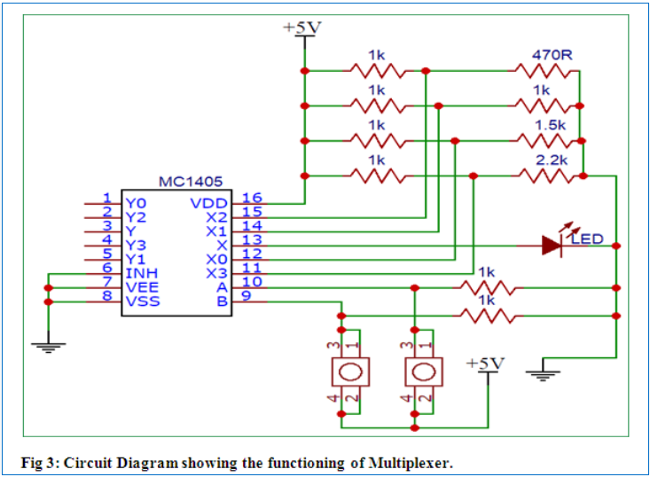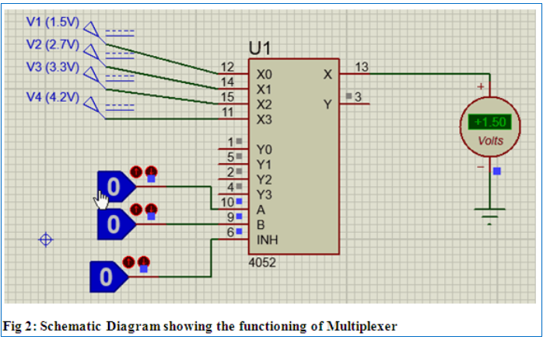

Circuit diagram om multisim live –

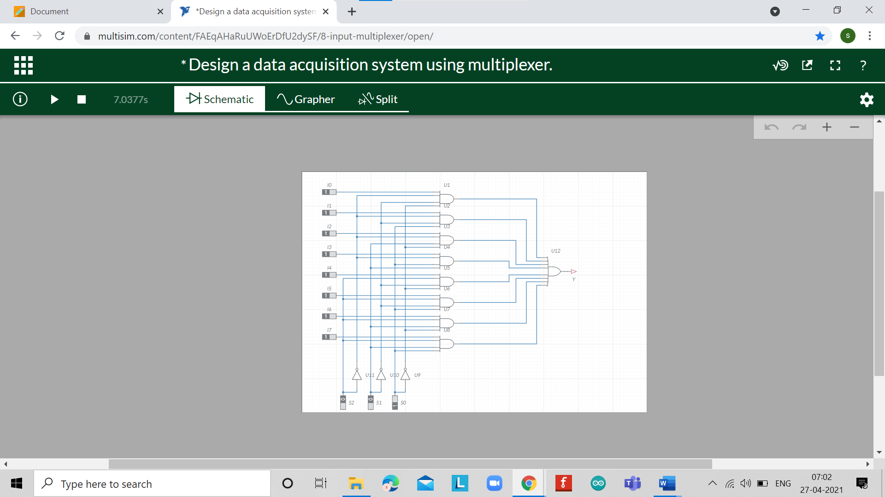

**Simulation Results:**

*(Insert simulation results ) )*At input 000 output is going to the 1st line of or gate

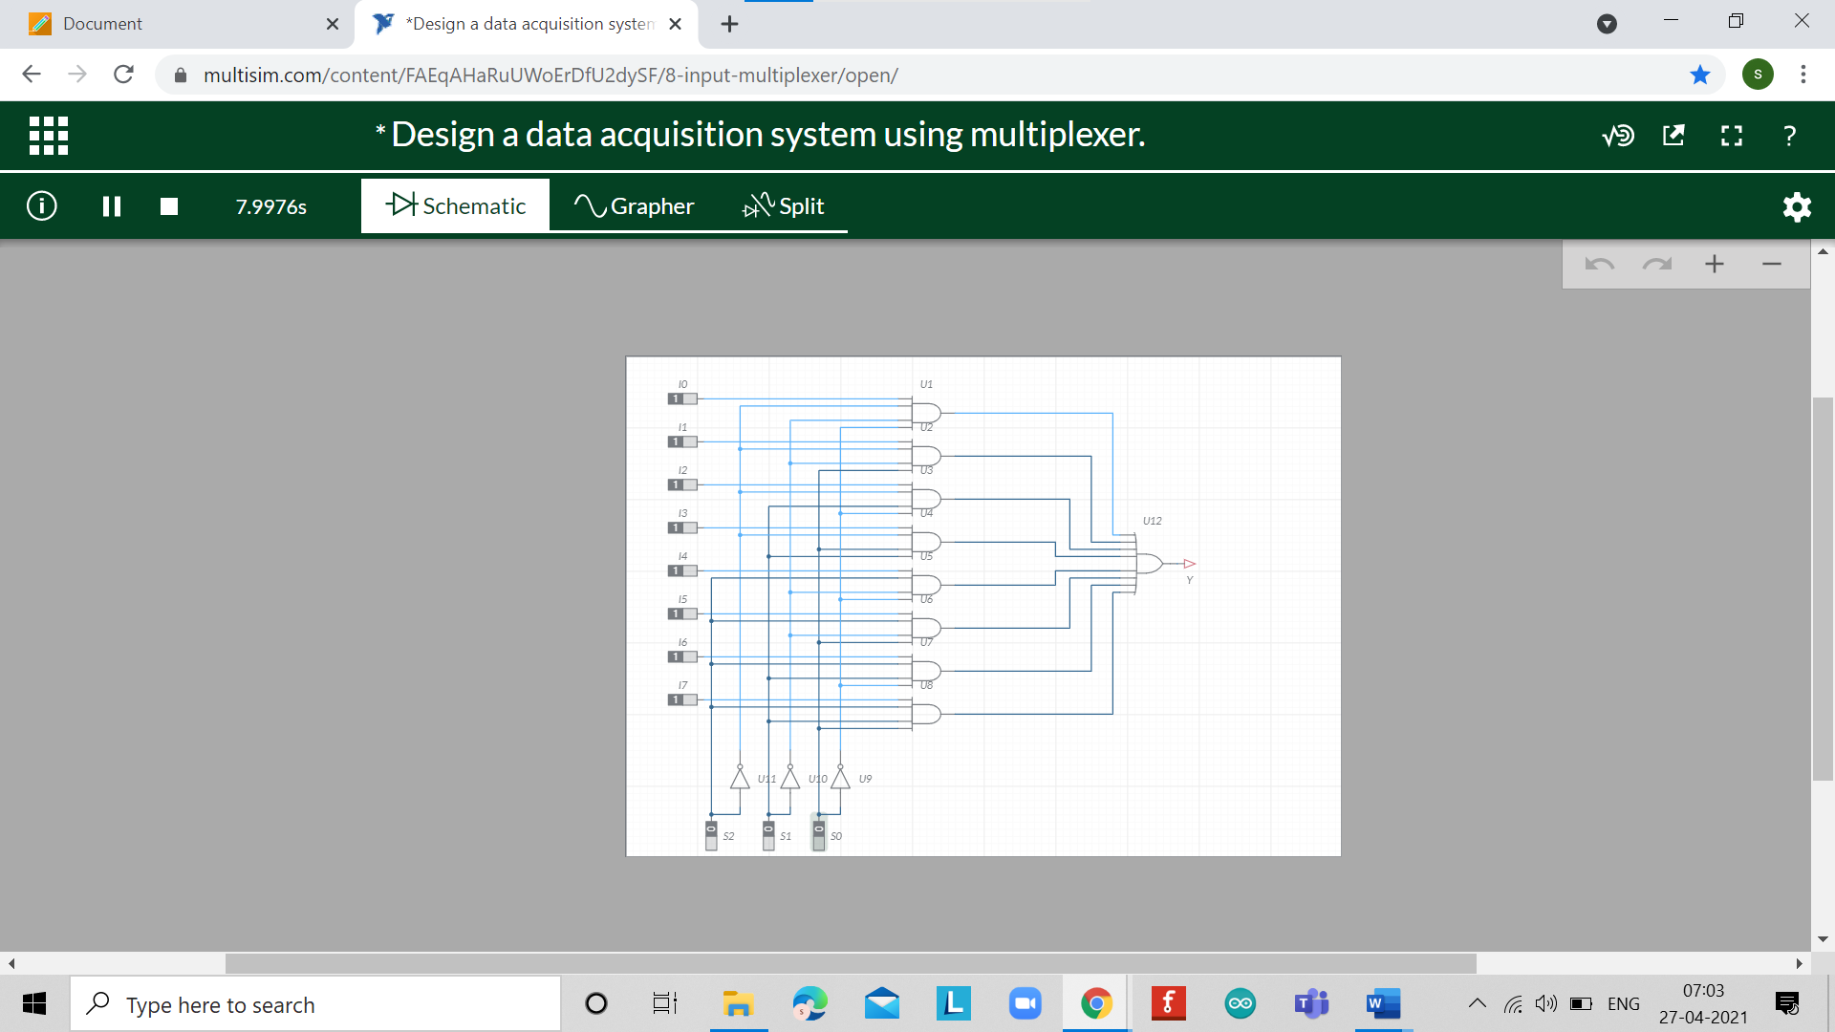

At input 010 output is going to the 3rd line of or gate

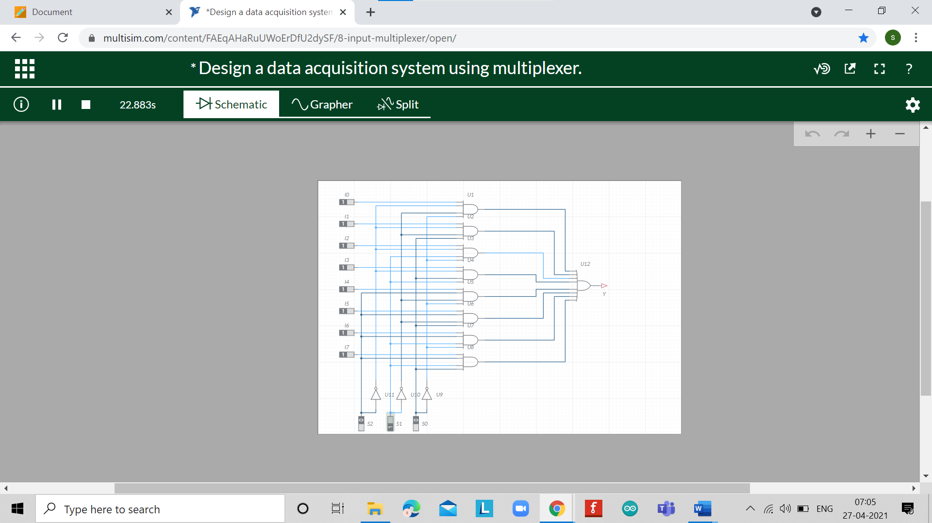

At input 111 output is going to the 8th line of or gate

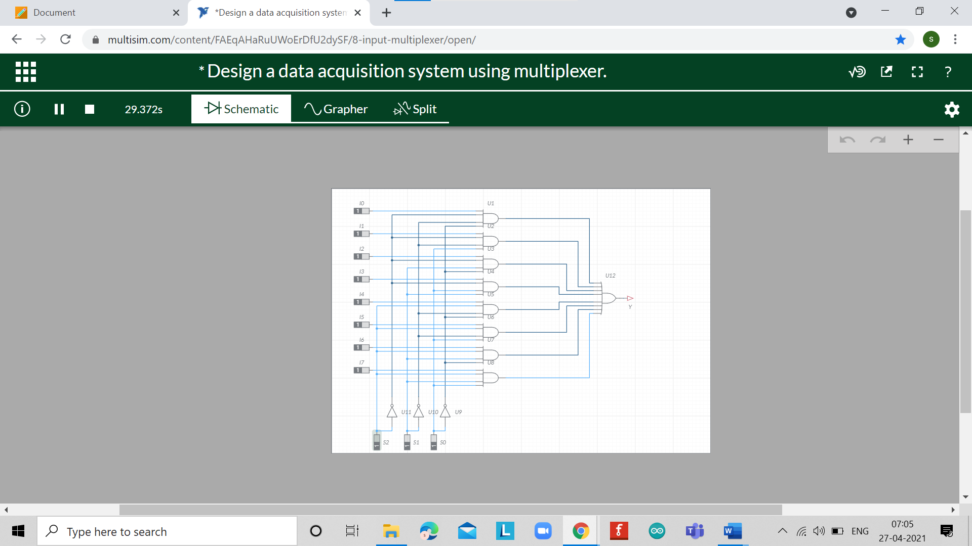

**Concept used**

*(Point out the concepts used in order to design the solution)*

* In this experiment we are using 11 digital constants like that on -off switch for giving logic input high and low.
* In which 11 digital constants 8 connected to the AND gate and other 3 is connected to Inverter which is used here to change the inputs.
* And one 8 -input -OR gate is used for the gate output at particular value
* When we give input at inverter via digital constant is 000 then the output is seen 1st line is highlighted and at 111 last line as per that corresponding values and output will got same.
* According this here we got use of multiplexer.

**Learning/ observation**

*(Observations made during the experiment and learnings for future reference)*

* Data acquisition (DAQ) is the process of measuring an electrical or physical phenomenon such as voltage, current, temperature, pressure, or sound with a computer. A DAQ system consists of sensors, DAQ measurement hardware, and a computer with programmable software. Compared to traditional measurement systems, PC-based DAQ systems exploit the processing power, productivity, display, and connectivity capabilities of industry-standard Computers providing a more powerful, flexible, and cost-effective measurement solution. In this experiment however, the focus is on DAQ system as an application of multiplexer & thus it is required to select and observe reading from any one of the input.

**Troubleshooting**

*(Problems encountered and how did you solved those)*

I got trouble in input & output pins of a decoder and with the connection of the resistors & wires of the circuit. I could able to solve my troubleshooting by proper knowledge of designing circuit.

**Result**: The Data acquisition system using Multiplexer has been designed and Implemented.